Guidance for Developing
Quality Science
Student Learning Objectives

August 2018

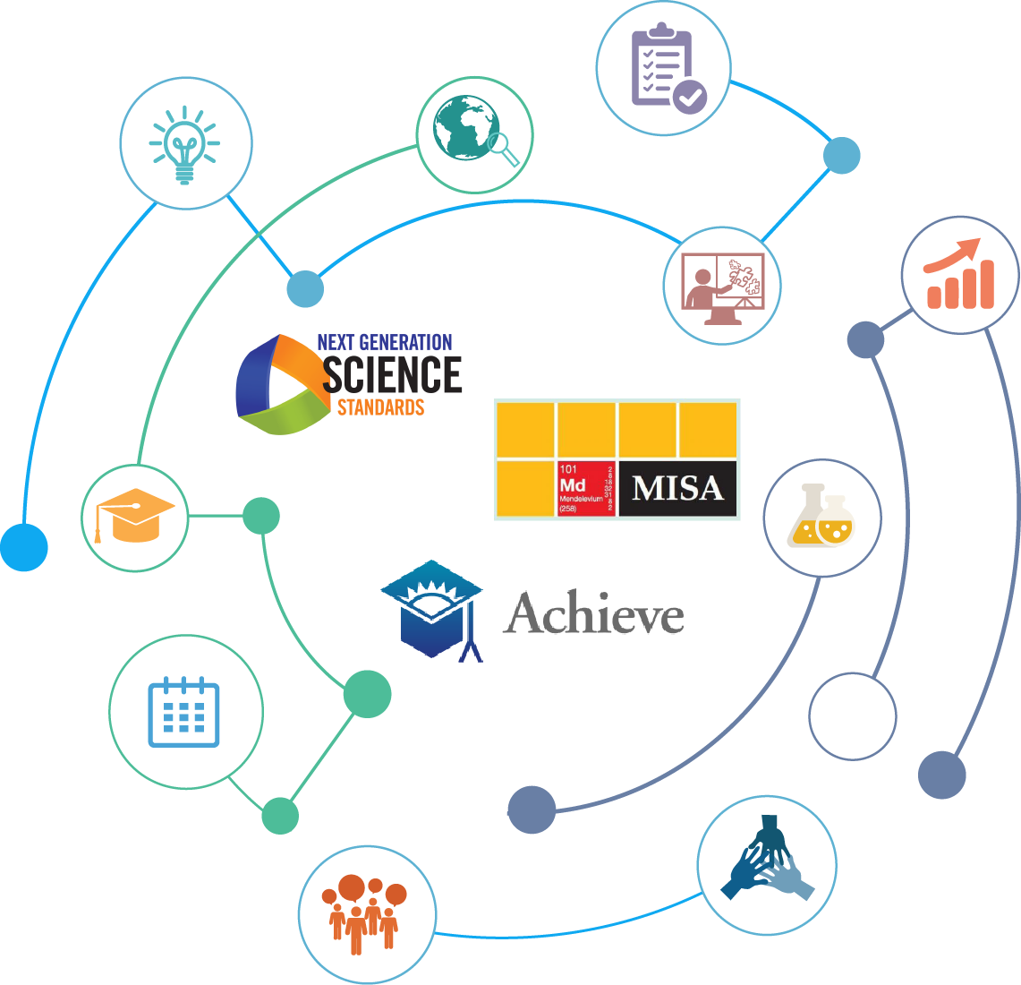

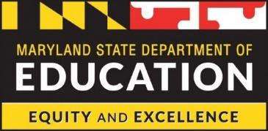

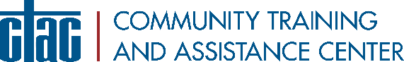

Table of Contents
Background on Key Science-Related Initiatives 1
Next Generation Science Standards (NGSS) 1
Maryland Integrated Science Assessment (MISA) 1
Student Learning Objectives (SLOs) 1
Purpose 2
Components of a Quality SLO 2
Students 3
Expectations 4
Standards 4
Toolbox 5
Instructional Interval 5
Evidence of Growth 6
Instructional Tools 6
Design Tool for Science Student Learning Objectives 7
Classroom Features of Three-Dimensional Science Instruction 8
School Features of Quality Science Instruction 9
References and Resources 10
Special Message from MSDE 10

Background on Key Science-Related Initiatives

Next Generation Science Standards (NGSS)
Recognizing the need for rigorous science standards based on the big ideas and practices of science, the Maryland State Board of Education adopted the Next Generation Science Standards (NGSS) on June 25, 2013. The NGSS is a set of rigorous and internationally benchmarked standards for K-12 science education. The Maryland State Department of Education (MSDE) provides guidance and professional learning experiences to support transition to these standards and to bolster the instructional practice of science educators across the state. The MSDE has also worked in partnership with local science supervisors to support school systems’ implementation of the new standards to monitor the implementation and to provide targeted assistance when needed. The measurement of student learning under NGSS has remained a priority for MSDE, which has led to the development of the Maryland Integrated Science Assessment (MISA). One of the more significant shifts of these new standards and assessment includes three-dimensional learning. These three dimensions are to be taught simultaneously during instruction and are made up of science and engineering practices, crosscutting concepts, and disciplinary core ideas. Learn more about three-dimensional learning here.

Maryland Integrated Science Assessment (MISA)
To measure students’ learning in science as defined by the new science standards, the MSDE has engaged stakeholders, Pearson, and Measured Progress to develop robust, aligned, and meaningful assessments for Maryland’s students. Student proficiency in science will be measured in grades 5 and 8 (see pages 115-116 of Maryland’s approved ESSA plan) and also in high school to meet diploma requirements (see COMAR section 13A.03.02.09), as the high school MISA will replace Maryland’s High School Assessment for Science. The assessments will be fully implemented in grades 5 and 8 in the spring of 2018 and in high school in 2019. After extensive field testing and analysis, the MISA assessments will be formatted to align with the three-dimensional instructional approach called for in the NGSS. The MISA structure for grades 5 and 8 includes 4 units: Units 1, 2, and 3 include 3 tasks each, which are based on scientific phenomena, with each task requiring 1 constructed response item and 5 other types of items; Unit 4 includes 1 task similar to those in Units 1, 2, and 3, with an extended task that may include a simulation. The MISA structure for high school includes five sessions: 2 item sets in each session based on scientific phenomena, with 1 constructed response item per item set and 5 other types of items for each set.

Student Learning Objectives (SLOs)
Maryland adopted Student Learning Objectives (SLOs) as a part of the State model for the student growth component of teacher and principal evaluation systems (see COMAR section 13A.07.09.05). SLOs are an evidence-based approach to measuring student learning that leverage educator expertise with regard to knowing their students, content, and pedagogy. While serving as a measure of student learning, SLOs also function as a vehicle for using data measures to inform long-term goals for students and how best to deliver instruction. The SLO process involves ongoing collaborative planning between educators and their supervisors, to articulate targeted expectations for student learning, discuss pedagogical strategies, and address professional supports needed for success. Once the goals are established, SLO implementation focuses on supporting educators and their students throughout the process, to ensure students attain high levels of learning. Student outcomes at the end of the SLO process are incorporated as a percentage of educators’ overall evaluation score. In a commitment to support SLO implementation, MSDE partnered with eight state-wide organizations in a historic memorandum of understanding to strengthen educator evaluations through SLOs. MSDE remains committed to supporting SLO quality, defined explicitly in the SLO Quality Rubric and other turnkey resources.

Purpose
The guidance in this document:

- Supports the alignment of SLOs to state-adopted standards and assessments
- Promotes three-dimensional instruction of science
- Suggests methods for using MISA and other data in SLOs
- Provides tools to support effective practice
- Aligns three mutually-reinforcing initiatives: NGSS, MISA, and SLOs

Components of a Quality SLO
The purpose of an SLO is to help students reach expectations for standards. To do that, teachers use a toolbox over an instructional interval, demonstrating evidence of growth. The image below helps teachers think about the interconnected decisions necessary for a well-crafted SLO. As research has shown, the thinking process counts in an SLO. (See page 31 of It’s More Than Money.)

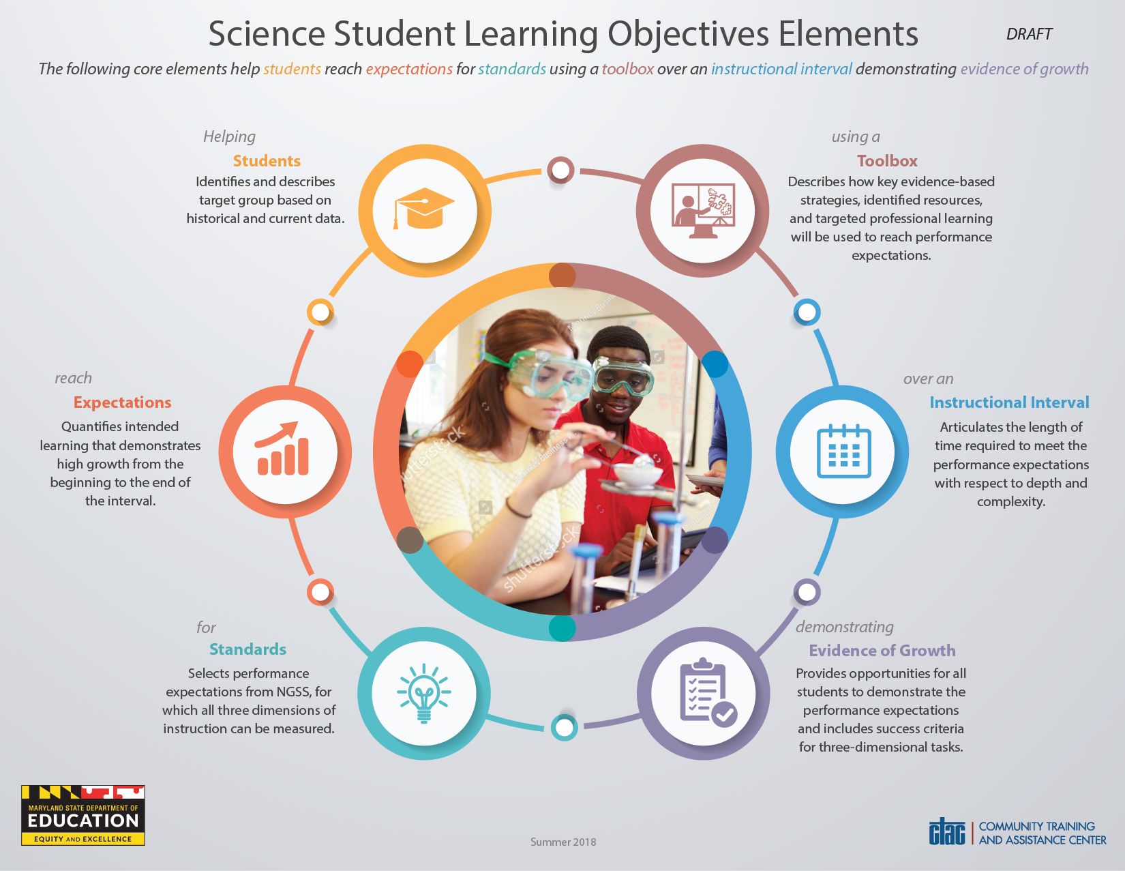
Download this tool: [Insert URL]

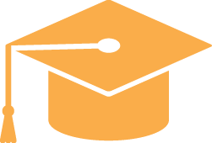

Students

Identifies and describes target group based on historical and current data.

This element supports an educator’s ability to diagnose student strengths and needs based on historical and current data. The target group includes the exact number of students, demographics for each student such as race, gender, special services, grade level, etc. In selecting students for the target group, careful consideration must be based on students’ needs as demonstrated on pre-determined measures or assessments. A high-quality SLO includes students’ strengths and needs as it relates to the what students should know and be able to do as identified in the performance expectations of the NGSS.

In deciding on the target group for an SLO, careful consideration needs to be given to ensure equity. An SLO is an opportunity to close gaps by focusing on particular students who have been underserved. As it relates to science instruction in particular, this includes the underserved populations of girls and students of color.

The result of this thinking is a specific set of students whose learning will be compared to goals set for or with them.

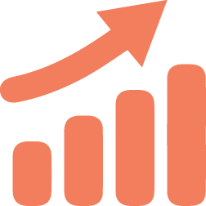
Expectations

Quantifies intended learning that demonstrates measured growth from the beginning to the end of the interval.

SLOs must include an initial data analysis and baseline for the current level of student learning in science. It is from this data analysis that instruction is informed. Science SLOs have a number of data points that can inform these expectations, which might include diagnostic tools, such as beginning-of-year assessments, benchmark assessments, or other vendor assessments. Other examples of data points to consider include early coursework, science notebooks, exit tickets, student surveys, anecdotal observation records, and any other source that directly supports students’ progress related to the identified performance expectations. In grades 5, 8, and high school, MISA provides detailed data on students at distinct points in their educational journey. These rich data sets inform the SLO but do not serve as the only baseline evidence source from which to determine growth, as they are integrated assessments that cover multiple years of content.

This results in decisions made collaboratively and based upon evidence: How will we determine whether students met the intended target? What was each student’s respective starting point as indicated by a measure? At the conclusion of the SLO interval, what would you expect each student to know and be able to do as a result of the strategies put into place?

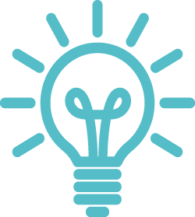

Standards

Selects performance expectations from NGSS, for which all three dimensions of instruction can be measured.

The NGSS sets forth performance expectations as the standards of student learning in science. The performance expectations each contain crosscutting concepts (CCCs), disciplinary core ideas (DCIs), and science and engineering practices (SEPs). These are referred to as the three dimensions in the NGSS. The NGSS recommends an instructional approach where students are taught science in an integrated manner, rather than discrete and separated ideas, concepts, and practices. This includes framing lessons around the performance expectations, which is how the MISA has been developed, to ensure alignment to the NGSS. To quote directly from the NGSS website, “The NGSS is not a set of daily standards, but a set of expectations for what students should be able to do by the end of instruction (years or grade-bands). Performance expectations set the learning goals for students, but do not describe how students get there.” Here is a 7-minute video to help better understand how to read the NGSS and how they are laid out.

Standards are where the exact NGSS performance expectations to teach and measure are selected. Performance expectations are the assessable statements of what students should know and be able to do. (Source: Understanding the Standards, NGSS)

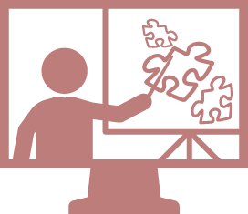

Toolbox

Describes how key evidence-based strategies, identified resources, and targeted professional learning will be used to reach performance expectations.

When planning for quality science instruction that is aligned to the NGSS, the performance expectations (PEs) are a key component embedded in each standard. These performance expectations guide teachers in developing lessons and units aligned to the MISA. In delivering 3D instruction students should have opportunities to construct their own learning from rich experiences provided in the classroom. Approaches such as student-based inquiry, hands-on investigations, and real-world experiences derived from authentic phenomena are some of the ways educators can support students’ learning. In building long-range and daily instructional plans, an inquiry-based mindset will guide the types of experiences planned for students. Quality science instruction is inquiry-based and integrated with real-world phenomena to align with NGSS.

In the toolbox section, describe how you will teach the learning selected, and what tools and supports are necessary to make that happen.

Instructional Interval

Articulates the length of time required to meet the performance expectations with respect to depth and complexity.
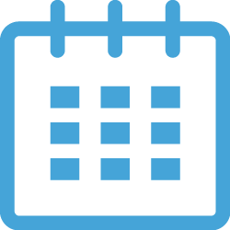
This element of an SLO is related to time. It is the interval in which teachers and students work to meet the target. Instructional calendars have limitations (e.g., the school calendar of events) which need to be considered so as to identify an interval that reflects the right amount of instructional time given these variables. Therefore, it is important to make determinations before the interval begins based on the time available. Effective three-dimensional science instruction yields deep understanding and application of specific content simultaneously with evolving understandings of big ideas. Ensuring there is a sufficient amount of instructional time for students to experience and interact in the depth and complexity of the selected standards is key.

The instructional interval is where the start and end dates for an SLO appear, and can be where a science storyline is described.

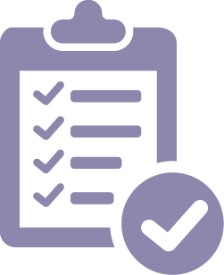

Evidence of Growth

Provides opportunities for all students to demonstrate the performance expectations and includes success criteria for three-dimensional tasks.

This portion of an SLO states what measures for students’ science learning will be used to determine how much growth has occurred.

A wide body of assessments are in use across Maryland for gauging the progress of student learning in science including classroom assessments, school assessments, and school system assessments. Most common in use across school systems is the MISA, given in grades 5, 8, and in high school. It is strongly suggested the MISA not be used as evidence of student growth for an SLO. As mentioned in the “Expectations” section, MISA provides rich data on students’ science learning at three points in their educational journey. The way MISA is structured (see “MISA” section above) can greatly inform the measures used for the Evidence of Growth in an SLO. Such assessments to determine growth in science learning need to be rooted in phenomena and should integrate the SEPs, DCIs, and CCCs. Evidence of Growth items need to require students to ground conclusions in evidence through a variety of methods of and for learning.

This is the element that sets forth the measures for students’ learning that will be used to determine growth.

Instructional Tools
Included are three tools that are used to:

- plan a specific SLO for a class,
- identify high-quality science instruction in a classroom, and
- identify high quality science instruction and support throughout a school.

Each of these tools can be adapted and used in many ways. On the next several pages are some suggestions for possible uses of the tools.

Design Tool for Science Student Learning Objectives
This tool can be used to help craft an SLO, or to talk with colleagues about an existing SLO. The six core elements (in the far left column) each have four design levels that help guide the development of that element. For example: In developing the element of “Students” for an SLO, it is an early and important decision to first identify whom exactly will be included in the SLO. Second, it is important to diagnose specific strengths and needs students have with regard to the identified standards. For those that want to further enhance the quality of this element, the third level points out that multiple data points can be used to corroborate that students need significant time and support with the identified standards. At the highest level of quality for this element, a broader understanding of students can be articulated that includes students’ experiences and interests which help inform the instruction to take place.

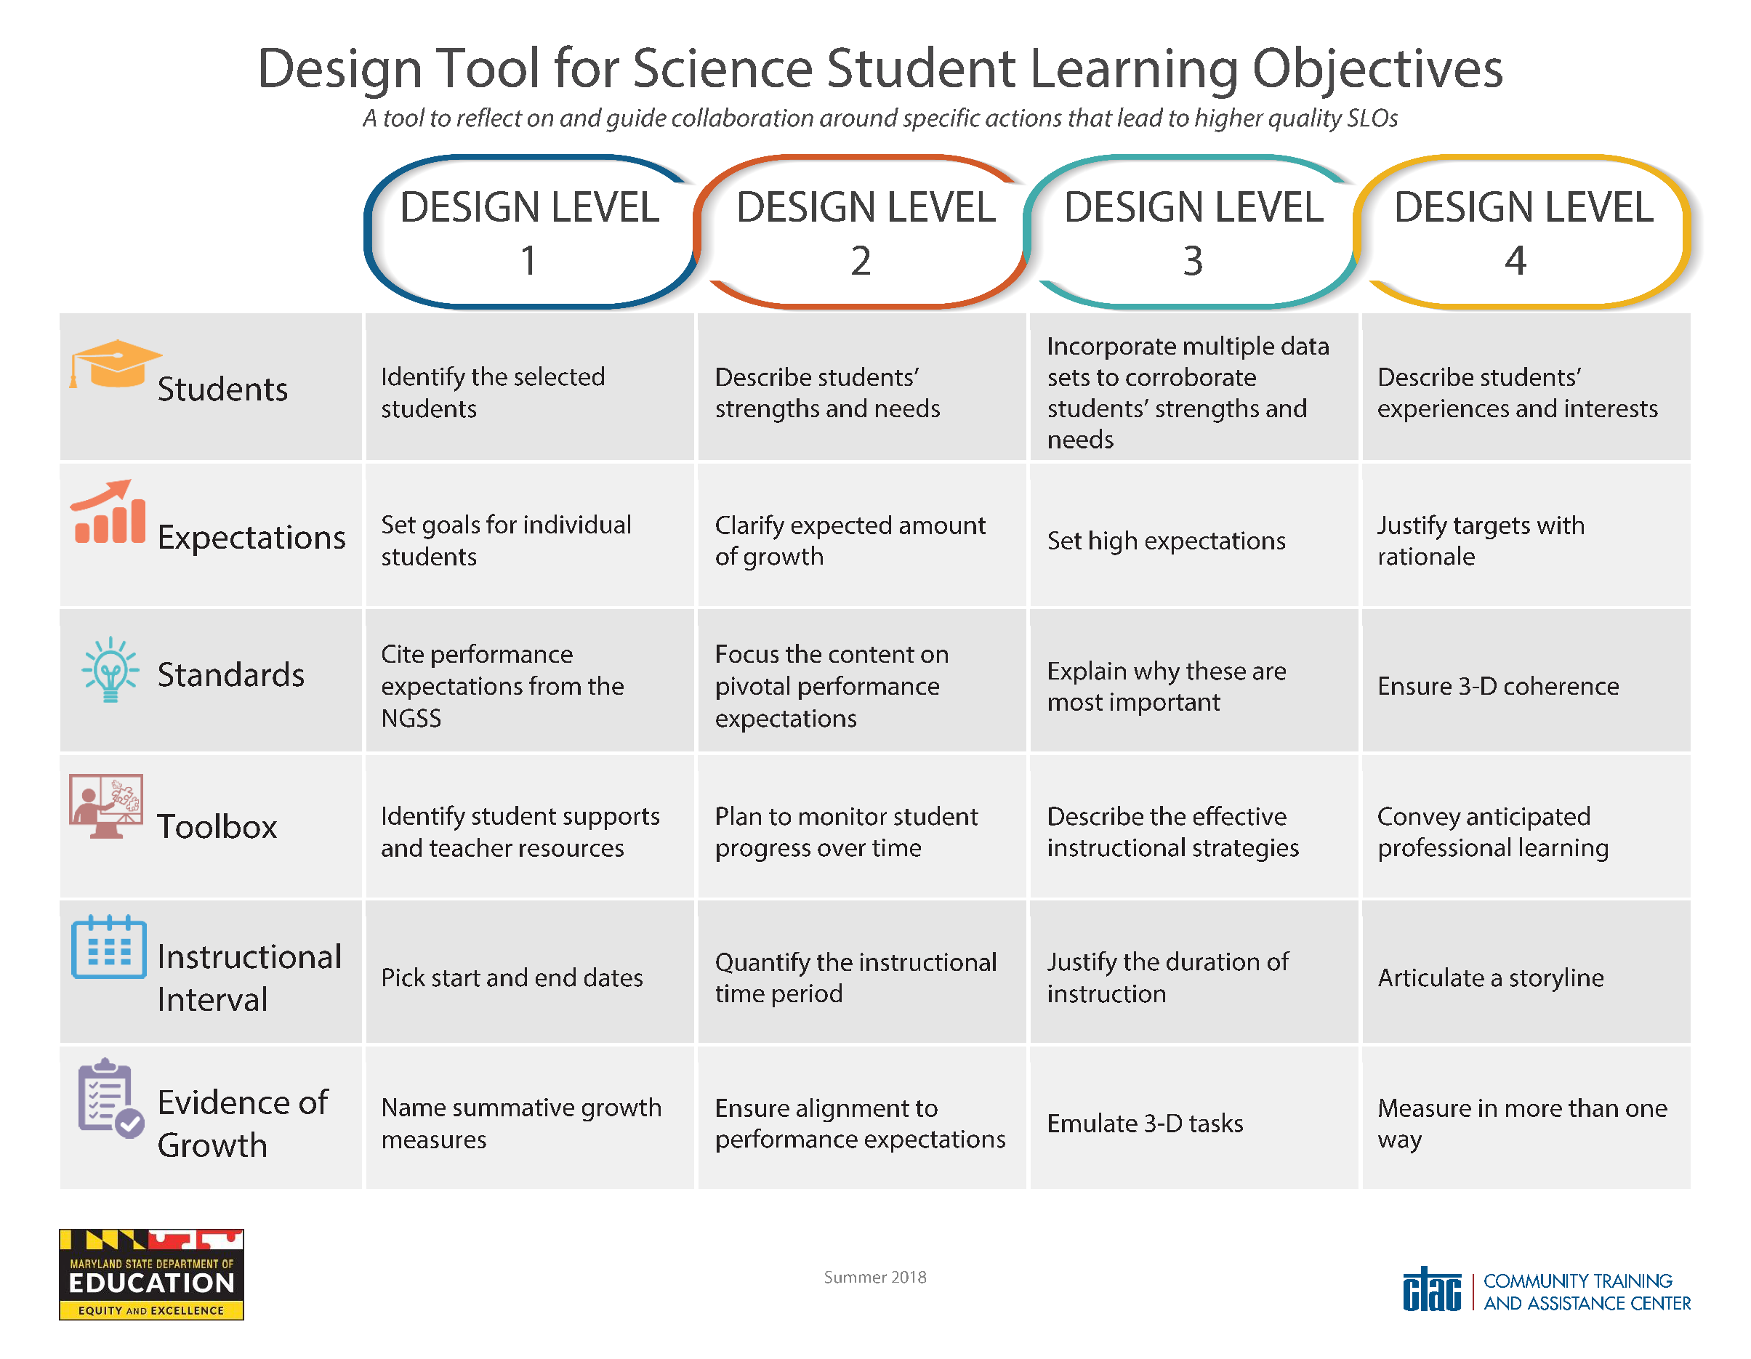
Download this tool: [Insert URL]

This tool can also be used by those developing or reviewing SLOs to identify the features present in the SLO. For those developing SLOs, the descriptors in each row point out key features to include to improve the quality of a given element. For those reviewing SLOs, the descriptors in each row can serve as a coaching continuum. For example, if the “Evidence of Growth” element contains the features in the first three design levels, the reviewer can work with the teacher on his SLO to discuss bringing in another measure of student learning to further enhance the quality of this element.

Classroom Features of Three-Dimensional Science Instruction
Teachers can use this tool to plan and deliver instruction throughout the interval. In the four outer corners of the document are key actions for teachers and students that should occur most of the time. These actions are intended to help teachers visualize how they will occur in class, making any in-the-moment adjustments as needed.

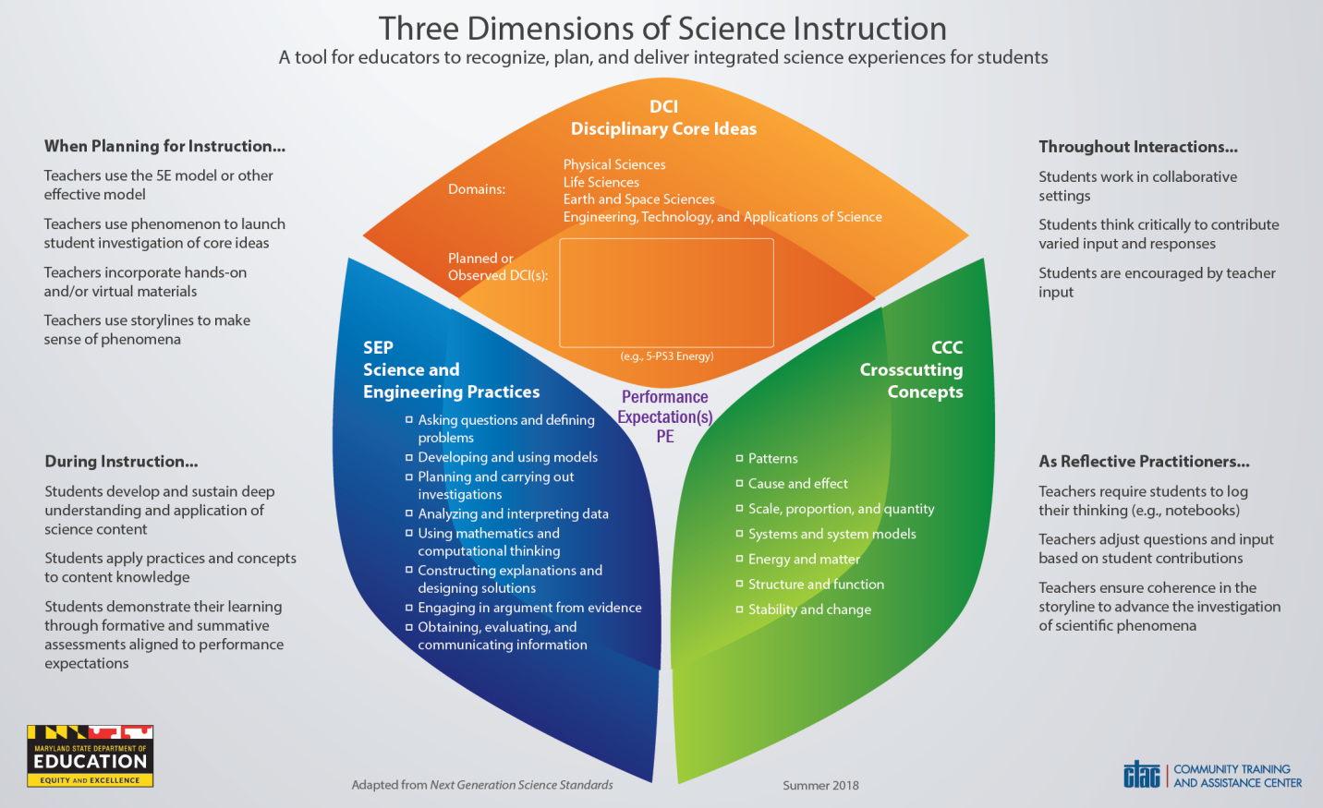
Download this tool: [Insert URL]

Teachers can use the interior “cube” shape to plan the intersection of the three dimensions of instruction. On the back of the document are the specific Disciplinary Core Ideas (DCIs) which can be included in the orange section of the “cube.” Each lesson needs to contain at least one Science and Engineering Practice (SEP) and one Crosscutting Concept (CCC), which are listed in the other two sections of the “cube.” In addition to identifying the DCI, a teacher can mark which of the SEPs and CCCs are to be incorporated throughout the lesson.

Administrators and other leaders can also use the tool to observe and support instruction with regard to the aspects found in the document. Observers of instruction can mark what aspects they see in the room, noting additional comments in the margin. The noted observations on the document can serve a post-lesson conversation well, by focusing on what aspects of three-dimensional instruction were present. Maintaining a log over time for one or more teachers can also serve to capture a broad picture of three-dimensional learning for a teacher or school.

School Features of Quality Science Instruction
This tool can be used to recognize the main features of a school providing integrated science instruction. Further, the tool can be used to plan and refine how science instruction takes place at a school.

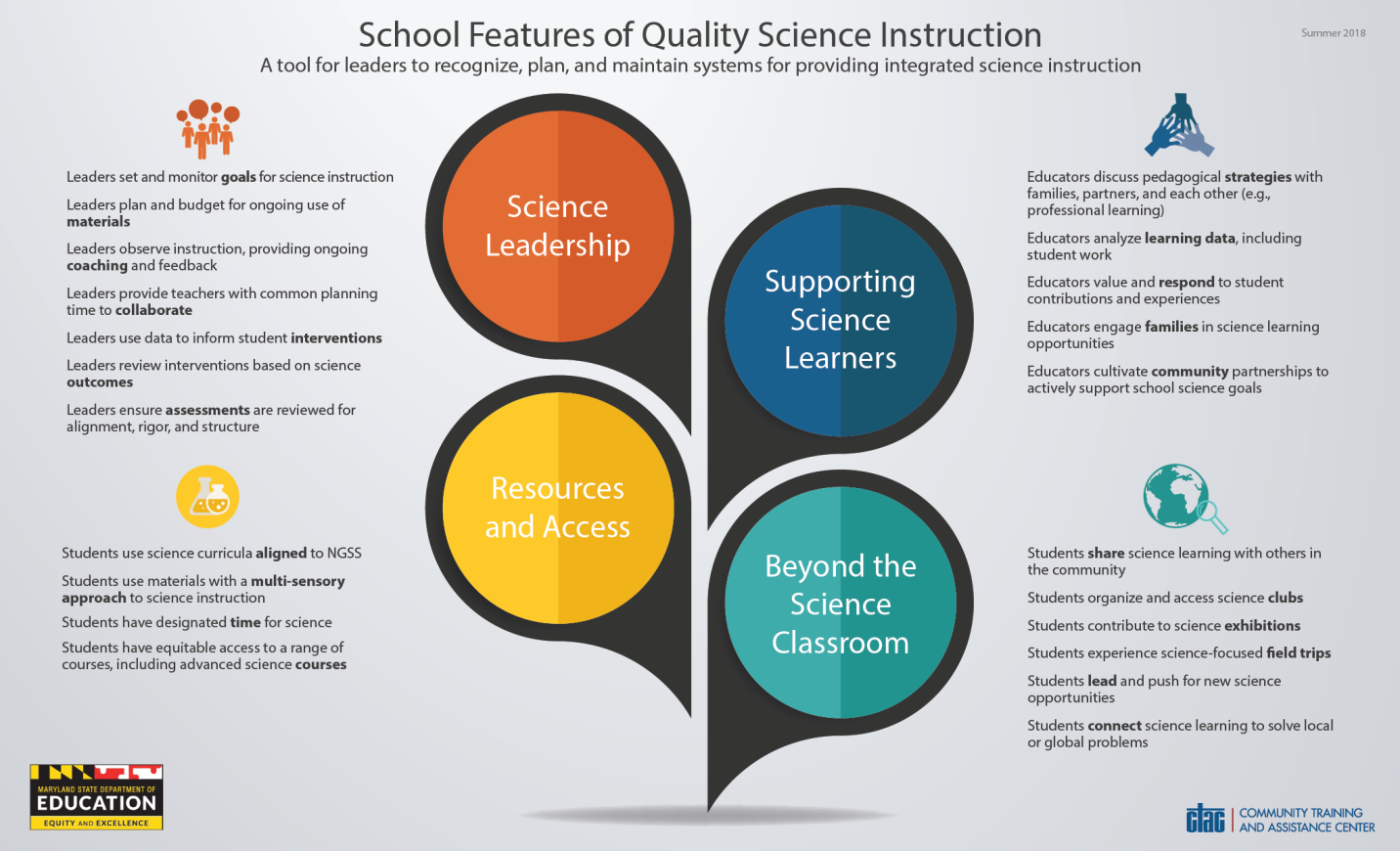
Download this tool: [Insert URL]
The school features in this document are actions that occur within a school and are categorized into four headings: Science Leadership, Resources and Access, Supporting Science Learners, and Beyond the Science Classroom. Each of the action statements holds educators and students responsible and provides guidance in developing three-dimensional quality science instruction. One use of the tool could be as an inventory or self-assessment for a school leader. Any features not present can serve to inform thinking about what supports might be needed to further enhance science instruction school-wide.

This tool can also serve as a companion while engaged in broader school improvement planning, ensuring that three-dimensional science instruction is prioritized.

References and Resources
Below are some key resources, hyperlinked as a reference for supporting the development and implementation of high-quality science SLOs. In addition to these web-based resources, school-based leaders (principals, assistant principals, department chairs, team leaders), school system leaders (science supervisors, resource teachers, curriculum specialists), and MSDE also stand ready to support this work.

- NGSS
- MISA
- Achieve
- MSDE SLO Resources

Special Message from MSDE
[insert special message from MSDE, could be around disclaimers, local control, state’s commitment to support, etc.]

