Evidence-Based
Intervention Guidance for Districts and Schools
What You Need to Know

Office of Leadership Development and School Improvement
August 2019 | © Maryland State Department of Education 2019

Table of Contents

Evidence-BasedInterventionGuidancefor DistrictsandSchools 0

Terms Defined 2
Introduction and Background 2
Getting Started 2

What are evidence-based interventions? 2

What determines whether an intervention is evidence-based? 4

Where can educators get started in searching for an evidence-based intervention? 5

How can readiness for effective implementation of an evidence-based intervention be determined?
.................................................................................................................................................................. 6

How does ESSA’s four levels of evidence apply to research clearinghouses, such as What Works
Clearinghouse? 6
What tools or online resources can educators use to locate evidence-based interventions? 6
Social and Emotional Improvement: 7
Leadership Interventions 7
Mathematics 8
Reading 8
Wide Range of Topics (Academic, Instruction, Research) 9
Citations 9

MARYLAND STATE DEPARTMENT OF EDUCATION

Karen B. Salmon, Ph.D., State Superintendent of Schools
Carol A. Williamson, Ed.D., Deputy State Superintendent of Teaching and Learning

Division of career and college readiness | OFFICE OF LEADERSHIP DEVELOPMENT AND SCHOOL IMPROVEMENT
Tiara Booker-Dwyer, Assistant State Superintendent
Edmund Mitzel, Executive Director, Office of Leadership Development and School Improvement
Laura Liccione, Coordinator of Academic Improvement
Dr. Brian Eyer, Coordinator of Leadership Development
Morrall Thompson, Coordinator for Systemic Improvement Dr. Li Wang, Data Analyst
Dr. Mary Minter, School Leadership and Turnaround Support Specialist
Dr. Felicia Lanham Tarason, School Leadership and Turnaround Support Specialist
Tara Corona, Continuous Improvement Specialist Teri Windley, Management Associate

Larry Hogan, Governor

The Maryland State Department of Education does not discriminate on the basis of race, sex, age, national origin, religion, disability, or sexual orientation in matters affecting employment or in providing access to programs and activities and provides equal access to the Boy Scouts and other designated youth groups.
For inquiries related to departmental policy, please contact:
Equity Assurance and Compliance Office Maryland State Department of Education 200 West Baltimore Street Baltimore, Maryland 21201-2595
410-767-0433 (voice)
410-767-0431 (fax)
410-333-6442 (TTY/TDD)

Introduction and Background
Terms Defined
Comprehensive Support and
Improvement (CSI)- CSI schools are identified by one or more performance indictors: academic achievement, graduation rate, academic progress, English language proficiency, and school quality and student success for the “All Students” group.

Targeted Support and Improvement (TSI)- There are two categories of TSI schools defined by specific student group performance.

Technical Assistance- support provided to local school systems in alignment with ESSA to support the identification, selection, implementation and monitoring of evidence-based interventions.

Evidence-Based Intervention- For interventions to be considered evidence-based, there must be at least one study which showed a statistically significant positive effect on students or other relevant outcomes. The effectiveness of the intervention must be measured in a rigorous experimental study to encourage a thorough and impartial review of studies.
The outcome of the evaluation will determine what, if any, level of evidence the intervention meets.
Getting Started

This guide is designed to support district and school leaders in developing an understanding of evidence-based interventions in alignment with requirements in the Every Student Succeeds Act (ESSA). Evidence-based interventions are practices or programs that demonstrates a statistically significant effect on improving student outcomes. ESSA requires the use of evidence-based interventions when using funding from some Title programs. This guide reviews the definition, selection, and implementation of evidence-based interventions.

What are evidence-based interventions?
As required under Maryland’s ESSA Consolidated Plan, schools identified for comprehensive support and improvement (CSI) must include evidenced-based interventions in action plans if they are using Title I funds. Interventions must be in alignment with outcomes of the root cause analysis and comprehensive needs assessment for the school. ^{i}
The term intervention should not be confused with the types of interventions associated with “response to intervention” or RTI. Instead, intervention, when used with respect to ESSA means an activity, strategy, program or practice, that falls under one category known collectively as an intervention. ^{ii}
Evidence-based means that an activity, strategy, or intervention

- demonstrates a statistically significant effect on improving student outcomes or other relevant outcomes based on—

  - strong evidence from at least 1 well-designed and well- implemented experimental study;

  - moderate evidence from at least 1 well-designed and well- implemented quasi-experimental study; or

  - promising evidence from at least 1 well-designed and well-implemented correlational study with statistical controls for selection bias; or

(ii)(I) demonstrates a rationale based on high-quality research findings or positive evaluation that such activity, strategy, or intervention is likely to improve student outcomes or other relevant outcomes; and

- includes ongoing efforts to examine the effects of such activity, strategy, or intervention (CCSSO, 2017).
Why use evidence-based interventions?
An evidence-based intervention, through controlled research studies, is one that has been proven to be effective in improving student outcomes. Knowing and building on what has worked in the past, and specifically for whom and under what circumstances can support informed decisions for selecting interventions that fit the context of the school.^{iii}

ESSA requires CSI schools using Title I funds to include interventions from Levels I, II, or III.

  - Level I - strong evidence it will impact student outcomes;
  - Level II - moderate evidence it will impact student outcomes; or,
  - Level III - promising evidence it will impact student outcomes.

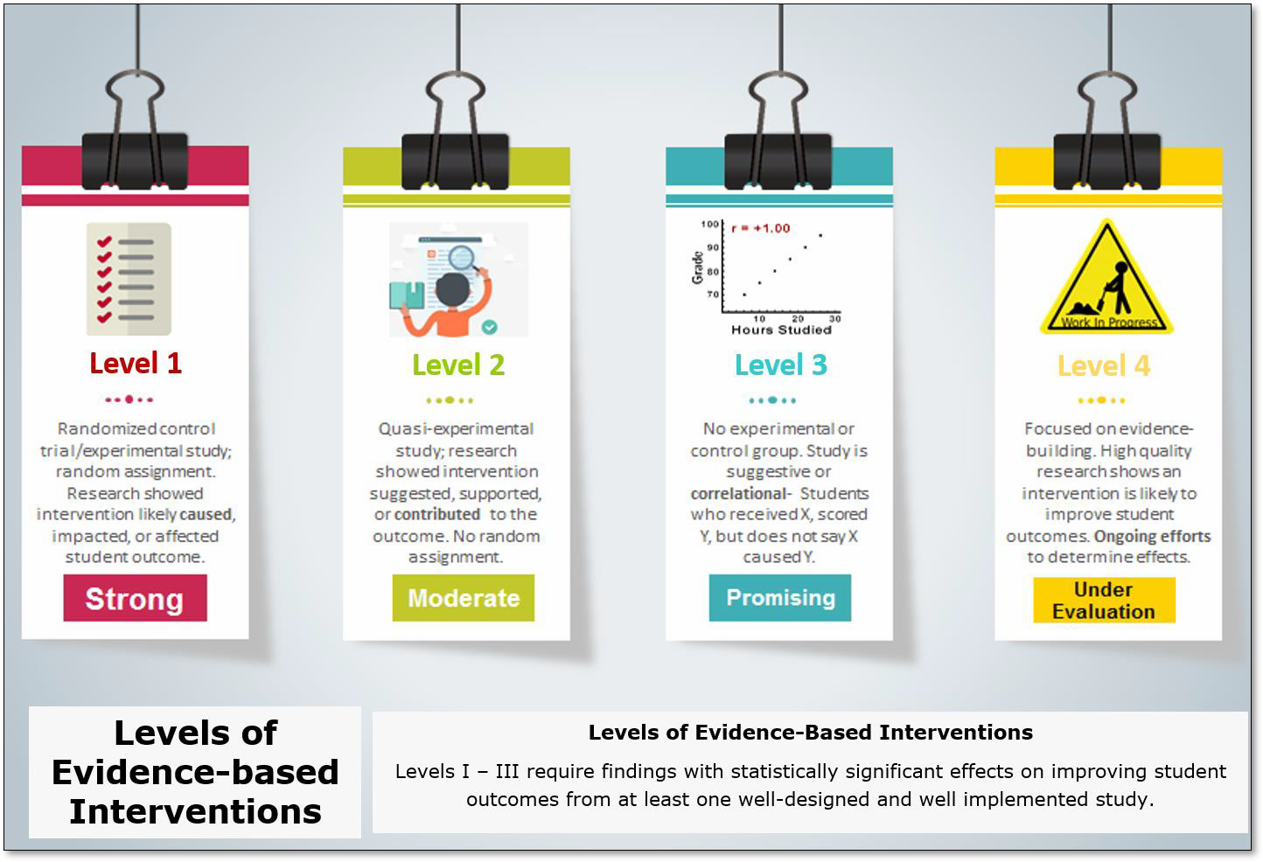
Figure 1. A graphic depicting the four levels of evidence as identified in Every Student Succeeds Act.

Since one of the broad intents of the Every Student Succeeds Act (ESSA) is to encourage evidence-based decision making as a standard practice, districts and schools must consider the appropriate solutions fits the needs. Unlike No Child Left Behind (NCLB), ESSA calls for the use of evidence-based activities, strategies, and interventions that produce positive results. With a lack of time and financial resources, selecting activities proven to be effective is the most responsible consideration ^{iv}because there is proof it will work, when implemented effectively.

For example, there is a substantial amount of research that points to effective school leaders as a powerful driver to positive student outcomes. Using this research as a starting point, school systems could investigate exactly what kinds of activities would be most beneficial in developing an effective principal or other leader. In the case of school leadership evidence-based activities, the research strongly indicates replacing staff and/or leader could have negative effects unlike a strong principal preparation programs which shows correlations to student achievement gains. ^{v}

What determines whether an intervention is evidence- based?
During No Child Left Behind (NCLB), education became more data-driven with terms like “scientifically based research” or “research-based”. These differences in terminology may seem negligible; however, under ESSA, the
term evidence-based intervention is more strictly defined through the use of four levels of evidence (see Figure 1). For an intervention to be considered evidence-based means it is supported by research that proved the intervention worked as intended.

Districts and schools who receive federal dollars under Title I must select from interventions that demonstrate either strong (Level I), moderate (Level II), or promising evidence (Level III). Schools who seek Title II funds can select interventions from any level (I – IV).

Level IV, under ESSA, states that the intervention, program, strategy, or practice must demonstrate a rationale based on high-quality research or a positive evaluation that suggests it is likely to improve student outcomes or other relevant outcomes. There must be ongoing efforts to evaluate the effect of the intervention and it must be developed through a logic model (also known as a theory of action).

Titles and Levels Under ESSA:

-Title I, Section 1003 (School Improvement) and CSI schools are required to have strong, moderate, or promising evidence (Levels I-III) to support them.

- Title I, Part A: Levels I- III

-Title II, Part A: Levels I-IV (Levels I and II should be prioritized, see guidelines on page 31 of “Non- Regulatory Guidance for Title II, Part A: Building Systems of Support for Excellent Teaching and
Leading”
-Title III- Levels I-IV

-Title IV, Part A: Levels I-IV

All action plans developed by schools identified for comprehensive support and improvement must include evidence-based interventions aligned to the results of the required root cause analysis and needs assessment.

Items to look for when reviewing evidence-based interventions include:

  - a clear description of the intervention;
  - who administered it; who received it; at what cost?
  - how the treatment group differed from what the control group received;
  - details about how the intervention is supposed to affect student or other relevant outcomes;
  - Effect size – the effect size varies depending on the size of the study; an example shows an effect size of 0.25 which means that an average student in one intervention group would be expected to have scored 0.25 standard deviation more than if they had participated in the other intervention group. ^{vi}

For more information on allowable uses within Title programs, go to the link: http://www.marylandpublicschools.org/about/Pages/DSFSS/EquitableServices/Index
.aspx.

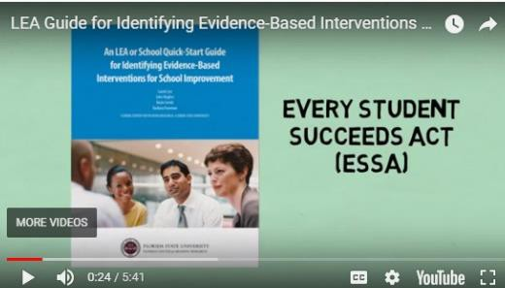
Where can educators get started in searching for an evidence-based intervention?

Five minute overview on how to get started and things to consider for evidence-based interventions.
Depending on what type of intervention is being sought to fit the needs of the school, teachers, students, and/or climate will determine where to search for an evidence-based intervention.

For a general overview, please the five-minute video entitled, “LEA Guide for Identifying Evidence-Based Interventions”. It briefly discusses how to get started and items to consider as school improvement plans are designed. Additionally,
recommendations are provided which closely align to the Four Domains of Rapid School Improvement, MSDE's framework for school improvement. The video describes self-study tools created by the Florida Research Center for Reading Research, available for download.

Video: Local Education Agency (LEA) Guide for Identifying Evidence-Based Interventions. A link to the 5-minute video: https://youtu.be/6-rbJK0HUtA
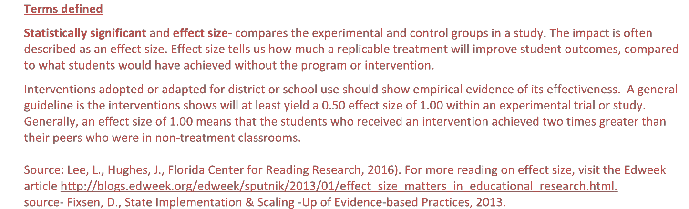

Terms defined
Statistically significant and effect size- compares the experimental and control groups in a study. The impact is often described as an effect size. Effect size tells us how much a replicable treatment will improve student outcomes, compared to what students would have achieved without the program or intervention.
Interventions adopted or adapted for district or school use should show empirical evidence of its effectiveness. A general guideline is the interventions shows will at least yield a 0.50 effect size of 1.00 within an experimental trial or study.
Generally, an effect size of 1.00 means that the students who received an intervention achieved two times greater than their peers who were in non-treatment classrooms.

Source: Lee, L., Hughes, J., Florida Center for Reading Research, 2016). For more reading on effect size, visit the Edweek article http://blogs.edweek.org/edweek/sputnik/2013/01/effect_size_matters_in_educational_research.html.
source- Fixsen, D., State Implementation & Scaling -Up of Evidence-based Practices, 2013.

How can readiness for effective implementation of an evidence-based intervention be determined?
There are a number of tools and assessments available to determine readiness on an intervention to be successfully implemented. What is more important is understanding why readiness is a necessary first step before actual implementation.

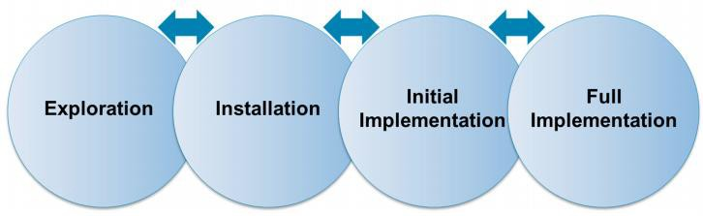
According to the State Implementation & Scaling Up of Evidence-based Practices (SISEP) Center, a leadership team should determine the level or the extent to which stakeholders are ready to implement a change and/or evidence-based practice. In this
context, readiness is defined as a “development point
at which a person, organization, or system has the capacity and willingness to engage in a particular activity.”
Readiness is critical for both initiating and scaling up the use of evidence- based interventions in education.vii

The Stages of Implementation from the UNC Child Development Institute www.scalingup.org

To provide assistance to districts and schools, the use of a tool developed by the National Implementation Science Network (NIRN) can service a resource to support planning for and/or assessing the use of stage‐ based activities to improve the success of implementation efforts. This tool can be used to assess current stage activities (e.g. “We are in the midst of Exploration”) or past efforts related to a stage (e.g. “We just completed most of Installation? How did we do? What did we miss?). For activities scored as “Not Yet
Initiated” the planning team may wish to: a) Examine the importance of the activity in relationship to achieving success; b) Identify barriers to completion of the activity; c) Ensure that an action plan is developed (sub‐activities, accountable person(s) identified, timeline, evidence of completion) and monitored. A ‘strength of stage score’ can be computed for each stage. View and download the tool.

How does ESSA’s four levels of evidence apply to research clearinghouses, such as What Works Clearinghouse?
It can be confusing to determine how one criterion aligns to ESSA levels of evidence. For example, What Works Clearinghouse (WWC) does not utilize terms like, “strong, moderate, promising”, or, “under
evaluation” as indicated under ESSA. Instead, WWC reviews and rates interventions uses ratings like, “meet standards without reservations, meets standards with reservations.” To help clarify how clearinghouse ratings align to ESSA, the Office of Leadership Development and School Improvement adapted a resource from the work of the American Institutes of Research (AIR) for the Ohio Department of Education.

What tools or online resources can educators use to locate evidence-based interventions?
To aid schools and school systems in locating interventions discovered from the comprehensive needs assessment and root cause analysis, a list of high-quality online sources follows. The resources are grouped within areas for improvement. This does not represent a full list.
Please note the Maryland State Department of Education does not explicitly endorse these resources. They are provided to assist school systems and schools in locating evidence-based practices, strategies and interventions aligned to the requirements in ESSA.

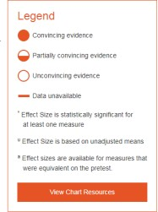
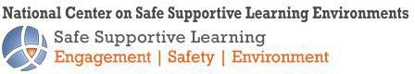
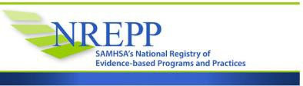
Social and Emotional Improvement:
- National Center for Safe Supportive Learning Environments- offers k-12 resources which includes Federal resources on human
trafficking, a school discipline guidance package, a school climate survey compendium, trauma-sensitive practices, social-emotional learning best practices and more.

- Substance Abuse and Mental Health Services Administration (SAMHSA) main website provides access to the National Registry of Evidence-based programs and practices (NREPP) to promote the adoption of scientifically established behavioral health interventions from birth to older adults. A wide range of topics are included in the database such as mental health, wellness, absenteeism, depression, The rating criteria is similar to other online intervention review processes in that it includes programs with effective outcomes; programs with promising outcomes; programs with ineffective outcome; and programs with inconclusive outcomes.

- National Center for Intensive Intervention- An interactive, searchable chart allows users to review studies about intervention programs in reading, math, and writing and/or by grade level- PreK through high school. Results are organized by study quality, study results, intensity, and by levels of evidence such as: convincing, partially convincing, unconvincing, or data unavailable. With filters, users can be selective about evidence-based programs they are trying to locate. Click on this link to access the interactive charts and information.

- What Works Clearinghouse Practice Guide: Preventing Dropout in Secondary Schools, September 17. This guide highlights four evidence-based recommendations for reducing dropout rates in middle and high schools and improving graduation rates. https://ies.ed.gov/ncee/wwc/PracticeGuide/24

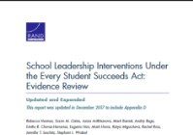
Leadership Interventions:
- Rand Corporation released an evidence report, School Leadership Interventions Under the Every Student Succeeds Act Evidence Review with important findings on school leadership as a powerful driver for improving education outcomes through specific, actionable evidence-based initiatives. The research answers important questions such as: What is the evidence that school leadership matters for school improvement? What school leadership improvement activities are supported under ESSA? Detailed information is available through the Rand Corporation site.

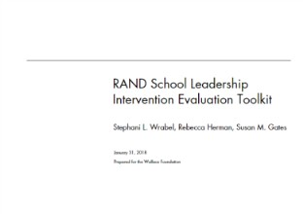
- Level IV interventions, under evaluation, are sometimes an option, depending on whether school systems or schools are attempting to use federal dollars under certain title programs. When it is appropriate to use Tier IV interventions, consulting the tool, Logic Models for Selecting, Designing, and Implementing Evidence-Based Leadership Interventions, developed by the Rand Corporation, may prove a good place to begin. This companion guide is designed for state and school system policymakers and other organizations responsible for leadership interventions. It guides users through a step-by-step process for understanding how logic models work and how these models organize the activities, inputs, outputs for each intervention aligned to the problem of practice.

- Rand Corporation released a 2018 web-only tool designed to help administrators responsible for implementing school leadership interventions evaluate the effectiveness of those efforts. The https://www.rand.org/pubs/tools/TL239.html toolkit provides guidance and support to determine whether the intervention is achieving the desired outcome.

Mathematics:
- ESSA for Evidence developed by the Center for Research and Reform in Education (CRRE) at Johns Hopkins University School of Education. Its purpose is to provide resources for educators that meet ESSA evidence standards.

- What Works Clearinghouse Practice Guide: Improving Mathematical Problem Solving in Grades 4 Through 8, May 2013. This guide offers five
recommendations for improving students’ mathematical problem solving in grades 4 through 8. The strategies show minimal, moderate, and strong evidence.

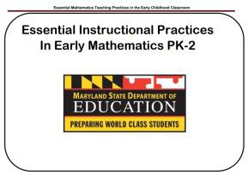
- Maryland State Department of Education: Essential Instructional Practices in Early Mathematics PK-2, 2014. A guide adapted from the National Council for Teachers of Mathematics (NCTM) highlights eight high-leverage mathematical teaching practices with applications for teachers.

Reading:
- ESSA for Evidence developed by the Center for Research and Reform in Education (CRRE) at Johns Hopkins University School of Education. Its purpose is to provide resources for educators that meet ESSA evidence standards.

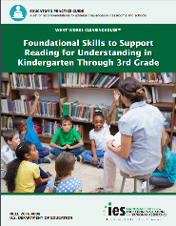
- What Works Clearinghouse: Foundational Skills to Support Reading for Understanding in Kindergarten Through 3rd Grade, 2016. A practice guide with four recommendations for teaching foundational skills including implementation steps and solutions for possible challenges.

Wide Range of Topics (Academic, Instruction, Research):
- Institute of Education Sciences (IES)- provides resources, research, evaluation, and statistics about education in the U.S. Through IES, anyone can access and use evidence that can be applied to education improvement.

  - Click on the hyperlink for more information: https://ies.ed.gov/

  - YouTube video (time-4:33), developed by the Institute of Education Sciences, is also available which provides an overview of all the services and features available to any user. To access the video, click on this hyperlink: https://www.youtube.com/watch?v=DeHf3UZV2nw

Citations:

i Leverage Points: Thirteen Opportunities for State Education Agencies to Use Their ESSA Plans to Build and Use Evidence to Improve Student Outcomes, Results for America, 2017.
ii Non-Regulatory Guidance: Using Evidence to Strengthen Education Investments, U.S. Department of Education, 2016.
iii Evidence-Based Improvement: A Guide for States to Strengthen Their Frameworks and Supports Aligned to the Evidence Requirements of ESSA, WestEd, 2017.
iv School Leadership Interventions Under the Every Student Succeeds Act: Evidence Review, Rand Corporation, 2017.
v School Leadership Interventions Under Every Student Succeeds Act: Evidence Review, Rand Corporation, 2017.
vi An LEA or School Guide for Identifying Evidence-Based Interventions for School Improvement, Florida Center for Reading Research, Florida State University, 2016.
vi Scaling-up Brief: Readiness for Change, State Implementation & Scaling-Up of Evidence-based Practices Center, September 2013.

Contact Information:

Maryland State Department of Education
Office of Leadership Development and School Improvement 200 West Baltimore Street
Baltimore, Maryland 21201-2595
Office Phone: 410-767-3676
410-333-6442 TTY/TDD
Online: Office of Leadership Development and School Improvement
MarylandPublicSchoools.org

