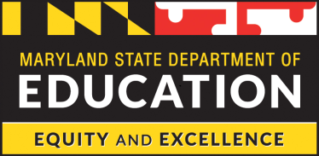

Comprehensive Support and Improvement (CSI) School
Intervention Plan Template
2019-2020 and 2020-2021

<Insert School Name>, <Insert Local Education Agency>

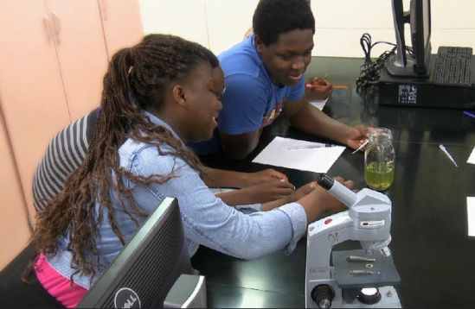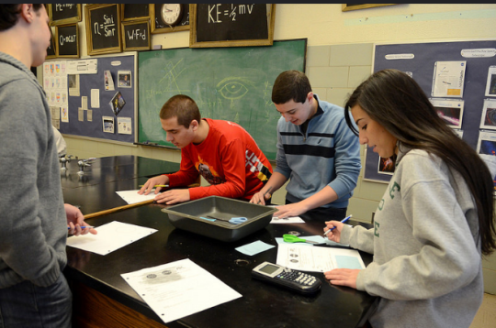
Table of Contents

Overview Pages 2-3
Background Pages 4-5
Intervention Plan Pages 6-12
Planning Guide and Directions Page 6
Prioritized Root Causes Pages 7
SMART Intervention Goals Pages 8-10
Evidence-Based Strategies Pages 11-12
Persons Responsible and Persons Involved Page 13
Budget Pages 14
Attestation Pages 15-16

This template and plan were developed with Federal Title I funds and are considered open source.

Overview

All Maryland Comprehensive Support and Improvement (CSI) schools receiving Title I School Improvement Funds are required to complete the needs assessment, 3rd party root cause analysis, intervention plan, budget, and attestation. The needs assessment, 3rd party root cause analysis, intervention plan and budget must be developed collaboratively with stakeholders and approved by the school, the district, and the Maryland State Department of Education, which will be affirmed in the attestation.

The purpose of the needs assessment and intervention plan is to: (1) identify and reflect on strengths and challenges in order to identify prioritized needs based on data analysis and root cause analysis findings; and (2) develop SMART intervention goals as the driver for an intervention plan that contains evidence-based strategies to address prioritized root causes.

The needs assessment and intervention plan are designed to be completed by a team and informed by data. The steps in the school improvement process, as outlined above, must be completed in partnership with stakeholders, including, but not limited to: the principal, other school leaders, teachers, representatives of teacher bargaining unit, community members, Local School System (LSS) content specialists, parents, and early childhood, business, and higher education partners.
Questions about the needs assessment, 3rd party root cause analysis, intervention plan, and budget development process for CSI schools may be directed to:

Dr. Marcia Sprankle Paula Harris
Assistant State Superintendent Director
Curriculum, Instructional Improvement &Professional Learning Title I - Program Improvement and Family Support
Maryland State Department of Education Maryland State Department of Education marcia.sprankle@maryland.gov paulam.harris@maryland.gov 410-767-0315 410-767-0321
Dr. Gail Clark Dickson Tricia Crafton
Supervisor, Title I - Program Improvement Coordinator, School Improvement/Title I
Maryland State Department of Education Maryland State Department of Education gail.dickson@maryland.gov patricia.crafton@maryland.gov 410-767-5153 410-767-3553
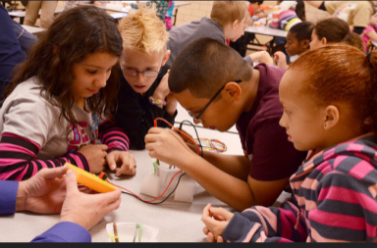
Background

Maryland's Consolidated State Plan under the Every Student Succeeds Act

The Every Student Succeeds Act (ESSA) was signed by President Obama on December 10, 2015. It replaces No Child Left Behind (2002) and revises the Elementary and Secondary Education Act of 1965 (ESEA). Each state was charged with writing a Consolidated State Plan for ESSA implementation.

Maryland’s ESSA Consolidated Plan identifies long-term goals for academic achievement, graduation rate, and English language proficiency. Maryland's ESSA Consolidated Plan can be found here: http://www.marylandpublicschools.org/about/Documents/ESSA/ESSAMDSubmissionConsolidatedStatePlan011018.pdf

Identification of Comprehensive Support and Improvement (CSI) Schools

Under the Every Student Succeeds Act (ESSA), Maryland is required to identify schools for Comprehensive Support and Improvement (CSI). The State must use the state-level accountability system developed under ESSA to identify CSI schools. CSI schools will be identified using all indicators in the State's accountability system, including academic achievement, academic progress, English language proficiency, and school quality/student success.
There are four categories of CSI schools identified in Maryland's Consolidated Plan. They are:
- Lowest performing CSI schools: the lowest achieving five percent of Title I schools in the State based on the "all students" group.
- Low graduation rate CSI schools: all public high schools in the State failing to graduate one third or more of their students (i.e. less than 67% of students are graduating) based on the four-year adjusted cohort graduation rate.
- School Improvement Grant (SIG IV) Schools: Existing SIG IV schools will be included in the Maryland CSI School list. The five Maryland SIG IV schools began implementation of a five-year SIG grant in 2016-2017. They will continue to utilize the Maryland Turnaround principles model, per the original grant application.
- Chronically low-performing: Any Title I school identified for targeted support and improvement for a low-performing or consistently underperforming student group that did not improve over three years. These schools will be identified for the first time in the 2022-2023 school year.
CSI schools will be identified for the 2018-2019 school year and will be identified at least once every three years. Schools will be required to update their Needs Assessment and Intervention Plan on an annual basis.

Support for Comprehensive Support and Improvement (CSI) Schools for 2019-2020

The MSDE will reserve seven percent of its annual Title I, Part A allocation for use in the 2019-2020 school year to support its CSI schools. For the 2019-2020 school year, these funds will be allocated by formula to LSSs with identified CSI schools for the implementation of their intervention plans based on a Per Pupil Allocation (PPA).

Maryland is committed to the continuous improvement of the state’s CSI schools. The MSDE will support LSSs and schools in identifying and prioritizing school needs through the needs assessment, including the third party root cause analysis; developing an intervention plan with evidence-based strategies; and implementing and monitoring approved intervention plans. The MSDE will participate in LSS Central Support Team and Turnaround Executive Support Team meetings and conduct learning walks to view evidence-based strategies in action. The MSDE will also leverage cross-divisional support to aid in the implementation of approved school intervention plans.

Intervention Planning Guide
The Maryland State Department of Education (MSDE) uses The Center on School Turnaround at West Ed’s Four Domains for Rapid School Improvement: A Systems Framework as the State framework for school improvement. Comprehensive Support and Improvement (CSI) school leaders will use this framework along with the templates on the following pages to prioritize needs and identify evidence-based strategies and action steps to address identified needs. Intervention plans must be collaboratively developed with stakeholders and approved by the school, the Local School System (LSS), and the MSDE.

Intervention Planning Directions
This template is designed to be a 1.5 year intervention plan outlining the programmatic goals and strategies for the CSI Schools. The plan will include SMART intervention goals and evidence-based strategies for semester 2 of the 2019-2020 school year (year 1) and the 2020-2021 school year (year 2). All CSI schools will craft an intervention plan for the 1.5 year timeframe and have the opportunity to edit the plan for the 2020-2021 school year (year 2) when 2019-2020 data is received. The 2019-2020 budget will be developed to fund the “year 1” plan (the goals and strategies for semester 2 and summer of the 2019-2020 school year). Additional information is forthcoming regarding the budget development process and timeline for year 2 (2020-2021).
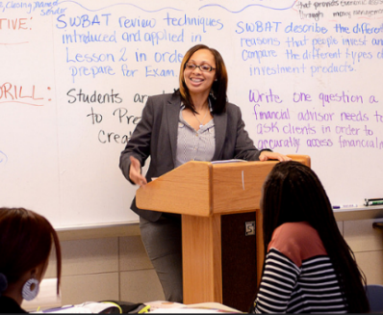

DIRECTLY FROM THE FINAL RCA REPORT
Prioritized Root Causes
Final set of root causes/underlying causal factors
Final Output. Prioritized Root Causes
1 | The verbatim language directly from the report goes here.
2 | The verbatim language directly from the report goes here.
3 | The verbatim language directly from the report goes here.
4 | The verbatim language directly from the report goes here.

Recommendations for Improvement
Key Strategies for Improvement
Primary Recommendations for Evidence-Based Improvement
Recommendation | Domain of Rapid School Improvement
The verbatim language directly from the report goes here. | The verbatim language directly from the report goes here.
The verbatim language directly from the report goes here. | The verbatim language directly from the report goes here.
The verbatim language directly from the report goes here. | The verbatim language directly from the report goes here.
The verbatim language directly from the report goes here. | The verbatim language directly from the report goes here.

NOTES:
- The MSDE will pre-populate the charts above directly from the RCA report.
- The school will demonstrate which recommendations for improvement they are prioritizing through the SMART intervention goals. Each school will develop no more than 3 SMART intervention goals based on what the school will prioritize in year 1. The plan will be modified to address additional prioritized root causes/recommendations for improvement in year 2 and year 3 of implementation.

SMART Intervention Goals
Directions: Based on the prioritized root causes, the school should develop no more than 3 SMART intervention goals in order to address the recommendations for improvement from the Root Cause Analysis report. Goals must be specific, measurable, achievable, realistic, and time-bound (SMART).

- Specific: Is the goal clearly defined?
- Measurable: Are concrete criteria identified for measuring progress toward attainment of the goal?
- Achievable: Does the goal stretch the school while still being attainable?
- Realistic: Does the goal relate to student learning and achievement? Is it data-based?
- Time-bound: Is the timeframe appropriate for accomplishment of the goal?

For each SMART intervention goal:
- Identify one or more of the Four Domains to which the goal aligns,
- Identify the annual outcomes for the goal (i.e. – what data will the school collect and measure to determine if this goal has been achieved?), and
- Identify the progress indicators* for the goal (i.e. – what data will the school collect and measure to determine if they are on track to meet the goal at any given point in time?).
  - Schools will identify progress indicators for various time frames (30 days, 60 days, quarter 2, and quarter 3).
  - Schools will also identify progress indicators related to both implementation (i.e. adult actions, systems, structures, and processes) and student outcomes.
*NOTE: Indicators are incremental checkpoints, data, or information used to assess progress toward achieving an outcome. How to pick leading indicators:
- Ask what data are indicative, or can help predict the outcome of interest before it happens
- Look at the various data points that would be available to the school, which are
  - Relevant
  - Clear and easy to understand
  - Provide enough detail for analyses and understanding
  - Robust and reliable and accurate
  - Seen as valid
- Analyze data to see if the data are useful for understanding the outcome (e.g., correlated or predictive)
- Might compare over time or different groups

Domains for Rapid School Improvement | SMART Intervention Goal | Annual Outcomes  (What data will the school collect and measure to determine if this goal has been achieved?) | Progress Indicators*  (What data will the school collect and measure to determine if they are on track to meet the goal at any given point in time?)
☐Turnaround Leadership  ☐Talent Development  ☐Instructional Transformation  ☐Culture Shift |  | 2019-2020:  Year 1, Semester 2 | Semester 2 Timeframe | Implementation Data | Student Outcome Data
 |  |  | 30 school days
 |  |  | 60 school days
 |  | 2020-2021: Year 2 | Timeframe | Implementation Data | Student Outcome Data
 |  |  | 30 school days
 |  |  | 60 school days
Quarter 2
(90 school days)
 |  |  | Quarter 3
☐Turnaround Leadership  ☐Talent Development  ☐Instructional Transformation  ☐Culture Shift |  | 2019-2020:  Year 1, Semester 2 | Timeframe | Implementation Data | Student Outcome Data
 |  |  | 30 school days
 |  |  | 60 school days
 |  | 2020-2021: Year 2 | Timeframe | Implementation Data | Student Outcome Data
 |  |  | 30 school days
 |  |  | 60 school days
Quarter 2
(90 school days)
 |  |  | Quarter 3
☐Turnaround Leadership  ☐Talent Development  ☐Instructional Transformation  ☐Culture Shift |  | 2019-2020:  Year 1, Semester 2 | Timeframe | Implementation Data | Student Outcome Data
 |  |  | 30 school days
 |  |  | 60 school days
 |  | 2020-2021: Year 2 | Timeframe | Implementation Data | Student Outcome Data
 |  |  | 30 school days
 |  |  | 60 school days
Quarter 2
(90 school days)
 |  |  | Quarter 3

Select Evidence-Based Strategies
Directions: For each SMART intervention goal, identify an appropriate evidence-based strategy that will be used to address the prioritized root cause. Once evidence-based strategies have been selected for each SMART intervention goal, school teams will provide the level of evidence for the selected strategy, a summary of the evidence highlighting school context, and the source citation for the evidence level. Additionally, school teams will identify professional learning needs, staffing needs, and resource needs for each evidence-based-strategy.
NOTE: No specific vendors should be named or selected as evidence-based strategies. According to ESSA, a strategy is evidence-based if the activity, strategy, or intervention demonstrates a statistically significant effect on improving student outcomes or other relevant outcomes based on one of three levels of evidence.
SMART Interven-tion Goal Number | Evidence-Based Strategy  Identify the strategies that will be used to address the need identified by the SMART Intervention Goal. | Level of Evidence  (Check One) | Evidence summary and evidence source/citation  (include citation link or reference) | Evidence that strategy fits school context  (e.g. demographics, location, grade level) | Professional Learning Needs to implement the evidence-based strategy | Staffing Needs to implement the evidence-based strategy | Resource Needs to implement the evidence-based strategy | Structures Needed for Implementation (Evaluation of Readiness - examples include master schedule, technology, curriculum, etc.) | Is this evidence-based strategy currently being utilized in the school?  (Check One)  If yes, indicate the length of time the strategy has been in use. | If yes, provide one of the following:  - a rationale as to why this strategy is effective as it is currently implemented, including detailed qualitative and quantitative data to support the effectiveness  - an explanation as to how the strategy will be implemented differently based on the research findings in the root cause analysis report
 |  | ☐ Level 1  ☐ Level 2  ☐ Level 3 |  |  |  |  |  |  | ☐ Yes  Length in use:  ___________  ☐ No
 |  | ☐ Level 1  ☐ Level 2  ☐ Level 3 |  |  |  |  |  |  | ☐ Yes  Length in use:  ___________  ☐ No
 |  | ☐ Level 1  ☐ Level 2  ☐ Level 3 |  |  |  |  |  |  | ☐ Yes  Length in use:  ___________  ☐ No
 |  | ☐ Level 1  ☐ Level 2  ☐ Level 3 |  |  |  |  |  |  | ☐ Yes  Length in use:  ___________  ☐ No
 |  | ☐ Level 1  ☐ Level 2  ☐ Level 3 |  |  |  |  |  |  | ☐ Yes  Length in use:  ___________  ☐ No

Evidence-Based Strategy – Persons Responsible and Persons Involved

Directions: Using the table provided, indicate the person(s) responsible, and the person(s) involved for each evidence-based strategy. Where appropriate, include the involvement of stakeholders and partners. List all persons responsible and persons involved by job title or role.

Evidence-Based Strategy  (insert directly from previous chart) | Person(s) Responsible  (list by job title/role, not by name) | Person(s) Involved, including Stakeholders and Partners  (list by job title/role, not by name)

Budget

All budgets will be completed in Microsoft Excel as an addendum to the application.

Link to 2019-2020 CSI School Budget Template

Note:
This template is designed to be a 1.5 year intervention plan outlining the programmatic goals and strategies for the CSI Schools. The plan will include SMART intervention goals and evidence-based strategies for semester 2 of the 2019-2020 school year (year 1) and the 2020-2021 school year (year 2). The 2019-2020 budget will be developed to fund the “year 1” plan (the goals and strategies for semester 2 and summer of the 2019-2020 school year). Additional information is forthcoming regarding the budget development process and timeline for 2020-2021.

Attestation

Section 1111 (d) SCHOOL SUPPORT AND IMPROVEMENT ACTIVITIES.— (1) COMPREHENSIVE SUPPORT AND IMPROVEMENT.—
- IN GENERAL.—Each State educational agency receiving funds under this part shall notify each local educational agency in the State of any school served by the local educational agency that is identified for comprehensive support and improvement under subsection (c)(4)(D)(i).
- LOCAL EDUCATIONAL AGENCY ACTION.—Upon receiving such information from the State, the local educational agency shall, for each school identified by the State and in partnership with stakeholders (including principals and other school leaders, teachers, and parents), locally develop and implement a comprehensive support and improvement plan for the school to improve student outcomes, that—
- is informed by all indicators described in subsection (c)(4)(B), including student performance against State-determined long-term goals;
- includes evidence-based interventions;
- is based on a school-level needs assessment;
- identifies resource inequities, which may include a review of local educational agency and school-level budgeting, to be addressed through implementation of such comprehensive support and improvement plan;
- is approved by the school, local educational agency, and State educational agency; and
- upon approval and implementation, is monitored and periodically reviewed by the State educational agency.

School Level Attestation
I certify the intervention plan and budget were collaboratively developed in partnership with stakeholders*. I acknowledge and confirm that the needs assessment and intervention plan have been approved by the school.
Principal Name: |  | Principal Signature: |  | Date:

Local School System (LSS) Attestation
I certify the intervention plan and budget were collaboratively developed in partnership with stakeholders*. I acknowledge and confirm that the needs assessment and intervention plan have been approved by the local education agency.
LSS Rep Name: |  | LSS Rep Signature: |  | Date:

Maryland State Department of Education (MSDE) Attestation
I acknowledge and confirm that the intervention plan and budget have been received for review and approval by MSDE.
MSDE Rep Name: |  | MSDE Rep Signature: |  | Date:
1st Submission Received: |  | 2nd Submission Received: |  | 3rd Submission Received:
1st Submission Feedback Sent to LEA |  | 2nd Submission Feedback Sent to LEA: |  | 3rd Submission Feedback Sent to LEA:
I acknowledge and confirm that intervention plan and budget have been approved by the MSDE.
MSDE Rep Name: |  | MSDE Rep Signature: |  | Date:

*Examples of activities demonstrating that the plan was “collaboratively developed with stakeholders” may include:
- Sign-in, agenda, notes, and evaluations (SANE) from Instructional Leadership Team meetings
- SANE from School and Family Council and/or Parent/Teacher Organization meetings
- SANE from Back-to-School Night
- SANE from Faculty Meetings or School Retreats
- Survey results requesting input and/or feedback on the goals and strategies
- Evidence that the plan was publicly shared and feedback was solicited
- Staff, student, parent, and community review and input in meetings

